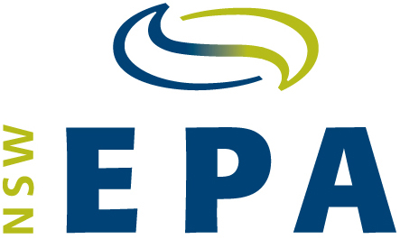
Certification:
Virgin excavated natural material
- I [full name]
of [organisation
and address]
certify that the waste as set out in section 2 of this notice is Virgin Excavated Natural Material (VENM) as defined in Schedule 1 of the Protection of the Environment Operations Act 1997.
This certification is made on behalf of the waste generator [fill out if applicable]
being [full name]
of [organisation
and address]
- The waste was generated at:
Street address:
Title reference (Lot/DP, etc.):
The amount of waste
(by volume or weight) is:
- I have made the determination that the waste is VENM because:
I have assessed the historical and current land use of the site at which the waste was generated.
The waste is not contaminated with manufactured chemicals, or with process
residues, as a result of industrial, commercial, mining or agricultural activities.
The waste does not contain any sulfidic ores or soils.
The waste does not contain any other waste.
The waste does not contain asbestos in any form.
Note: that all sections of this form must be completed including all boxes checked in
Section 3 above and signed below for any material to be certified as VENM.

Signature(s) |  | . . . . . . . . . . . . . . . . . . . . . . . . . . . . . . . . . . . . . . . . . . . . . .
Name(s) (printed)
Date

Warning: There are significant penalties under s.144AA of the Protection of the Environment Operations Act 1997 for a person who supplies (whether knowingly or not) information that is false or misleading in a material respect about waste.

This certificate is intended to assist waste generators, contractors and/or receivers of VENM to have confidence that a range of relevant factors have been considered in the classification of a waste material as VENM.

Published by:
Environment Protection Authority, 59–61 Goulburn Street, Sydney South 1232
Ph: 131 555. TTY users: phone 133 677, then ask for 131 555
Speak and listen users: phone 1300 555 727, then ask for 131 555
Email: info@environment.nsw.gov.au; Web: www.epa.nsw.gov.au
Report pollution and environmental incidents: Environment Line: 131 555 (NSW only)
EPA 2013/0693; September 2013

